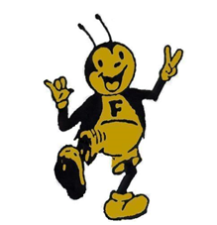

FOWLER USD 225

FOWLER, Kansas

 | DISTRICT INFORMATION  FACITILITIES  Buildings  - Fowler Grade School, grades PreK-5  - Fowler Jr./Sr. High School, grades 6-12  - The Dome – Gymnasium and community storm shelter  - Industrial Arts Building  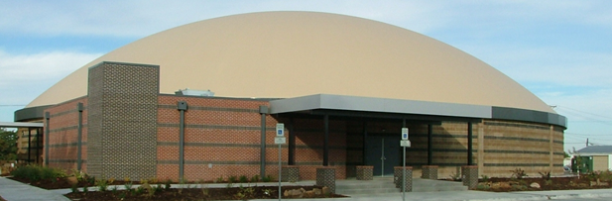  _____________________________________________  DISTRICT HIGHLIGHTS  - Gemini I District  - 4 Element Evaluation (E4E) for evaluation process  - At-Risk and Special Ed services  - Low student to teacher ratio  - 1:1 iPads for grades K-5  - 1:1 Chromebooks for grades 6-12  - Promethean boards in classrooms  - Special Ed services from SKACD District 613  - Music, art and shop programs  - Experienced and dedicated staff  - Local scholarships available for graduates  - Large % of graduates go on to post-secondary institutions  - Dual credit courses offered through distance learning  - Project-based learning  - Limited homework  - Social Emotional Character Development (SECD)  - Booster Club | 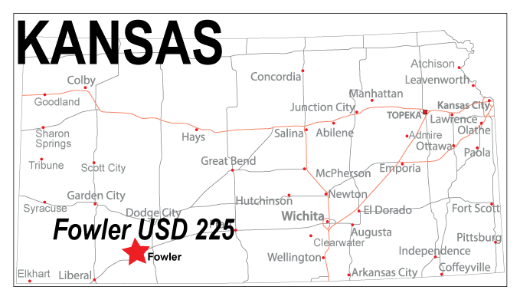  FOWLER USD 225 VISION STATEMENT  Fowler School District will provide a personalized and rigorous education that creates opportunities to build foundational knowledge and demonstrate application in real life scenarios.  We believe that all students need to prepare for a future beyond high school, whether that is to attend a postsecondary four-year program, a two-year program, a vocational/industry trades program or entering into the workforce.  Fowler School District 225 will create experiences through our educational models that meet the standards of the Five “R”s as described in the KESA model: Relationships, Relevance, Responsive Culture, Rigor and Results. This will be accomplished through a variety of teaching strategies, including classroom instruction, simulation and real-life experiences beyond the schoolhouse doors.  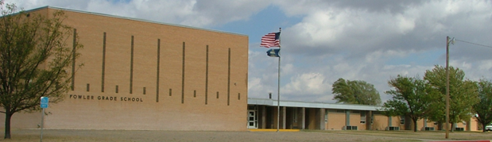
Fowler USD 225 – A Gemini I School
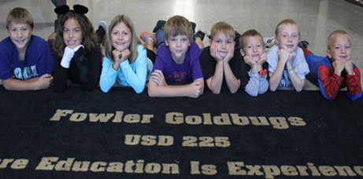  Grade School Highlights  - 3-year-old and 4/5-year-old preschool programs  - Standard-based report cards  - Stem Lab  - Grade School gymnasium (PE and recess use)  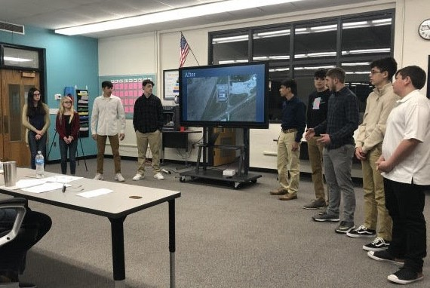  High School Highlights  - 1A high school offering both athletic and non-athletic programs, such as:  - Volleyball, football, basketball, track, scholars bowl, NHS, forensics, cheerleading, band, and cross country  - High school credit options for middle school students  - Individual Plan of Study  - Internship  - Civic Engagement  - Alternative content delivery: Distance learning, off-site courses, and web-based content  - Career and Technical Education (CTE) pathways  - Two gyms (high school and dome)  - FFA Chapter | OUR SCHOOL COMMUNITY  - The Fowler School District serves a community with a population of approximately 500. The City of Fowler is located 30 miles south of Dodge City, Kansas.  - USD 225’s district is in Meade County and portions of Ford and Gray Counties.  - City Amenities: A restaurant, two gas stations, convenience store, bank, auto part store, bed and breakfast, 4 churches, medical clinic, nursing home, post office, tax services, senior center, 3 hair salons and a beverage store, auto mechanic, auto body repair, art center, equity exchange and consignment shop.  - Recreation opportunities including swimming, wellness center, library, City Park, 2 ball fields, golf course with Frisbee golf and a wide variety of activities provided by the recreation commission.  - Youth Activities: Sports, 4-H, Church youth group activities and trap shoot team.  - Community Events:  - Annual Threshing Days events, parade and concert.  - 4th of July Firework Show  - Christmas festival and visit from Santa  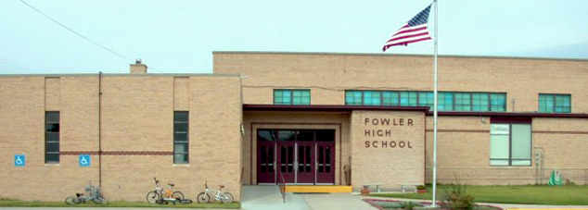
Fowler USD 225 – Where Education is Experienced

